**SMART MANHOLE MONITERING SYSTEM**

Authors: Jimit.P.Desai, Nagbhusan Pai, Nitish Penumetsaa ,Yagini Rautela

**Abstract:**

With the technological advancements, every application from our day to day life is becoming Internet-oriented, leading to the concept of Internet of Things (IoT). Various IoT devices and applications can be combined together for making a Smart City where smart drainage system is essential. However, drainage waste is both difficult to detect and manage. In many cities in India, it is very common for people to fall into uncovered manholes and for manholes to overflow . Thus, it is essential to manage the drainage/manhole effectively so that they do not obstruct the way of the drainage system. There have been few isolated works focusing on underground drainage monitoring or drainage system management only. However, very little work has been done in the area of detecting solid wastes accumulated within drainage . In this paper, we have aimed at solving the particular reason that causes overflow and to manage that cause efficiently. We have proposed a detailed IoT based drainage management system that also incorporates drainage waste management to make the system more effective. We have tried to develop a system that prevents and manages the solid wastes that are responsible for creating blockage inside drainage pipelines and drain covers.

1. **INTRODUCTION:**

As water supply and sewage infrastructure are built for the cities, it is required to maintain the drainage system. Drain conditions ought to be monitored to keep up its correct performance. Bad monitoring leads to blockage in the drainage, because of this it triggers flooding in the neighbourhood. If the improvement action is taken on time-related to drainage block, which will become a serious problem in the daily lives of people living in urban areas and if the drainage block remains for a long period due to increased waste matter, then it will produce harmful gases, which will affect the human health. It is well-known that, the management system of drainage is not digitized and so it is difficult to find out which drainage is blocked in a specific location. Due to the waste, harmful gases like methane, carbon monoxide, etc. are produced. This adversely affects the worker's health and they may also get new diseases. In addition to these , sometimes anti-social elements try to break open manhole cover and try to cut/damage the power lines passing through these drainages.This problem can be solved by using IoT Technology. By using IoT technology, the data can be obtained from the sensors, which are connected to the Arduino that sends data through the cloud. In the past few years, survey says that the death rate of sanitation employees has increased due to unaware of harmful gases, which are present in the drainage because it is known that, gases are odourless, and it is important to respect them because they risk their lives for maintaining healthy cities and this can be overcome by using the IoT technology.

The proposed system designed a model which will tells about the grazing the level of water, temperature region and pressure at intervals of hole to see whether the lid of the hole is opened or not. Besides, it monitors underground places in power lines. The important issues with this vogue unit of measure low value, low maintenance, quick activity and also a high variety of sensors and services. In addition to these features we also aim at detecting the accumulation of solid wastes inside manholes and give timely alerts to concerned authorities.

Sewer overflow of a town with an outsized floating population, which will stuff quantities in a sewage and contamination weakness of that stuff which will prevent from sewage flooding and it also differing the quality of the waste material individually.

This system is projected to build the city infrastructure by the effective use of ict which is sensors based for water level checking and blockage to reduce the problem of drainage issue in urban areas.

The system includes a Raspberry Pi4 microcontroller that is interfaced with completely different sensors (proximity, water level sensor, LDR’s, PIR sensor, Methane detecting gas sensors etc..) that collect knowledge and transmit it to the raspberry pi4controller. The results obtained by the various sensors are transferred to the raspberry pi microcontroller and this info is distributed to the individual government personnel through the message facility. The full system is effectively monitored and enforced victimization web of things.

1. **PROPOSED SYSTEM:**

The proposed system design has been classified into three parts:

1. Manhole Monitoring System
2. Intrusion Alert System
3. Overflow/Waste Management System

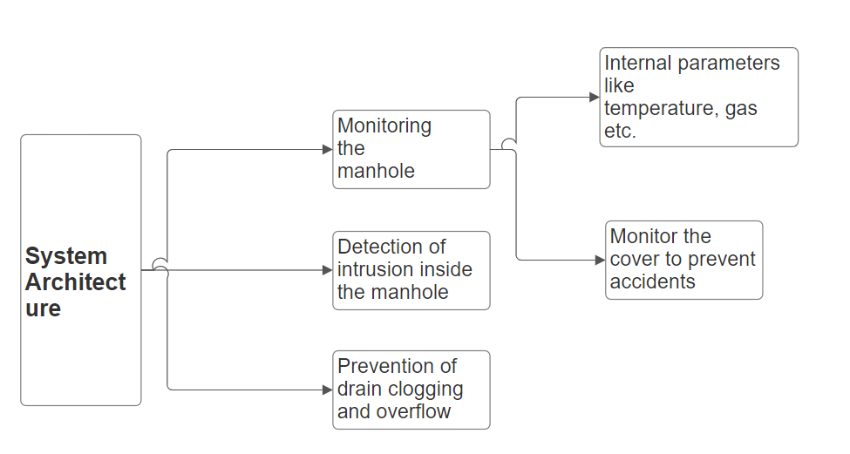

In our planned system, it includes the Raspberry Pi4 Microcontroller, ultrasonic sensor, Gas sensor, LDR’s, water level sensor, Pir sensor, limit switch. The ultrasonic sensor detects the intrusion inside the manhole. The gas sensor detects the harmful gases which are produced by the wastage in drainage. The limit switch is used to detect the absence of the manhole cover. All the data will be collected by the RaspberryPI4 and send through the cloud on the IoT webpage (Think Speak). It also gives the location of the device through GPS and sends sms alerts to concerned authorities.

1. **Project Implementation:**

The Drain wise system will have: Sensors to find blockage, flood and gases. The intelligence of sensors and system will verify the impeding inside the system and might offer the most points of the position and various data for extra actions. The system additionally can sense the presence of various harmful gases like methane series (CH4), oxide (SO2), CO (CO) etc. because the level of such gases pass the sting worth the system will generate the alert exploitation alarm system by that the Health department will take correct action thereon. The module is implemented exploitation wireless device networking technology each node will carry its own data beside the information of neighboring node and might pass it to next node by hopping techniques. These entire data packet square measure jointly sent by the entree node and keep at the cloud of those data square measure accessible in amount state of affairs for continuous observation.

1. **Block Diagram:** A diagram of a diagram

   Description automatically generated



1. **Hardware Implementation:**

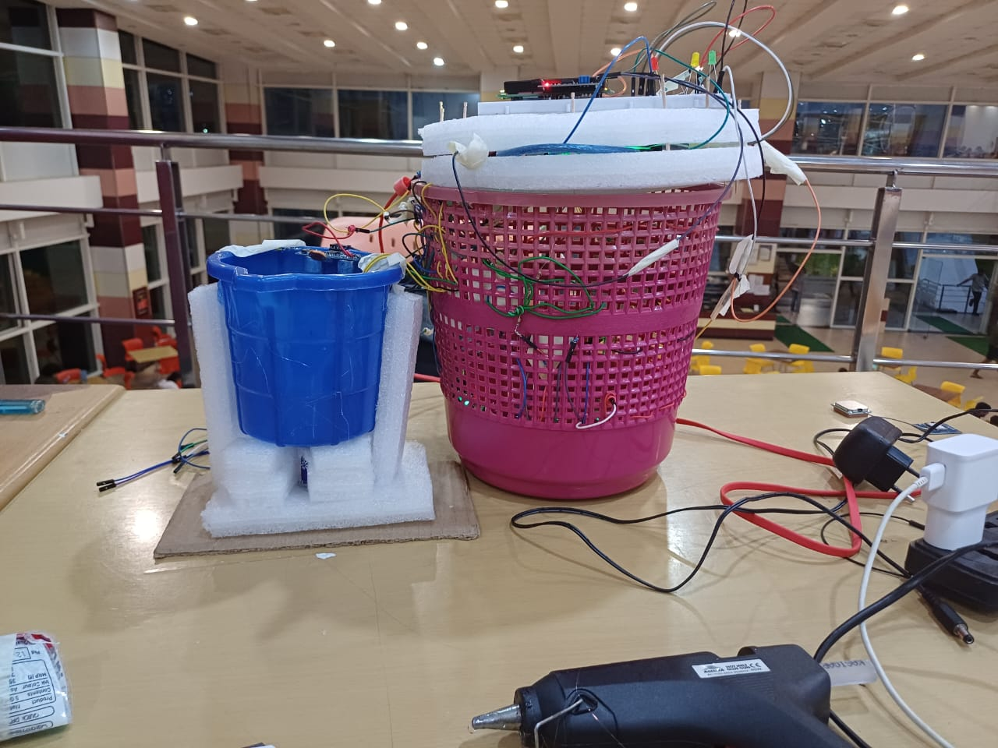

Fig (1) Fig (2)

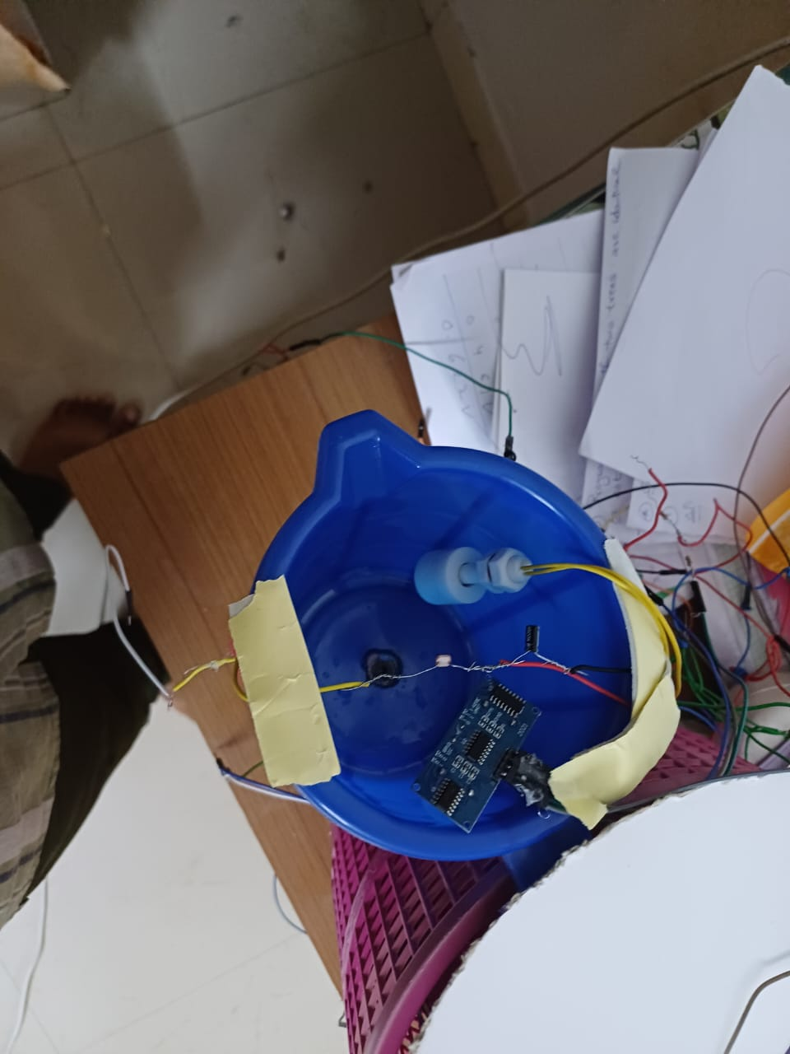

Fig (3)

Fig 1 is a visual of the prototype we have successfully created. Just below this manhole cover we have integrated limit switch which indicates the presence of manhole cover . During flash flooding / due to unforeseen reasons if the cover gets tempered with ,we can use the data from this sensor to monitor cover health.

Fig 2 gives us the glimpse of internal structure of our (a) Manhole Monitoring System and (b) Intrusion Alert system. As you can see that flame sensor, gas sensors and temperature sensors are integrated below the manhole cover where the pipelines are located .Also at the bottom the ultrasonic and pir sensors are fixed to detect human motion and to measure their proximity from the bottom of the manhole ,an area where power lines and pipeline pass through.

Fig 3 gives us the glimpse of the overflow/waste management system. As one can see, the ultrasonic sensor and float sensor works together to monitor the water/fluid level in the drainage. Ultasonic sensor is supposed to be situated at the top of the cover while float would be somewhere in the middle of the manhole. The LDR located at the top takes the reading using laser situated at the bottom ,as solid waste gets accumulated the intensity of the light coming from bottom decreases this change reflects in the readings of LDR .

1. **RESULTS;**
2. **Monitoring System**

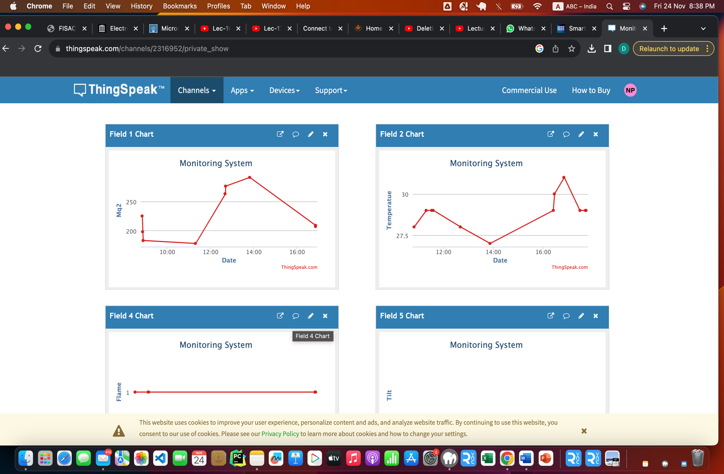

**Fig(4) Fig(5)**

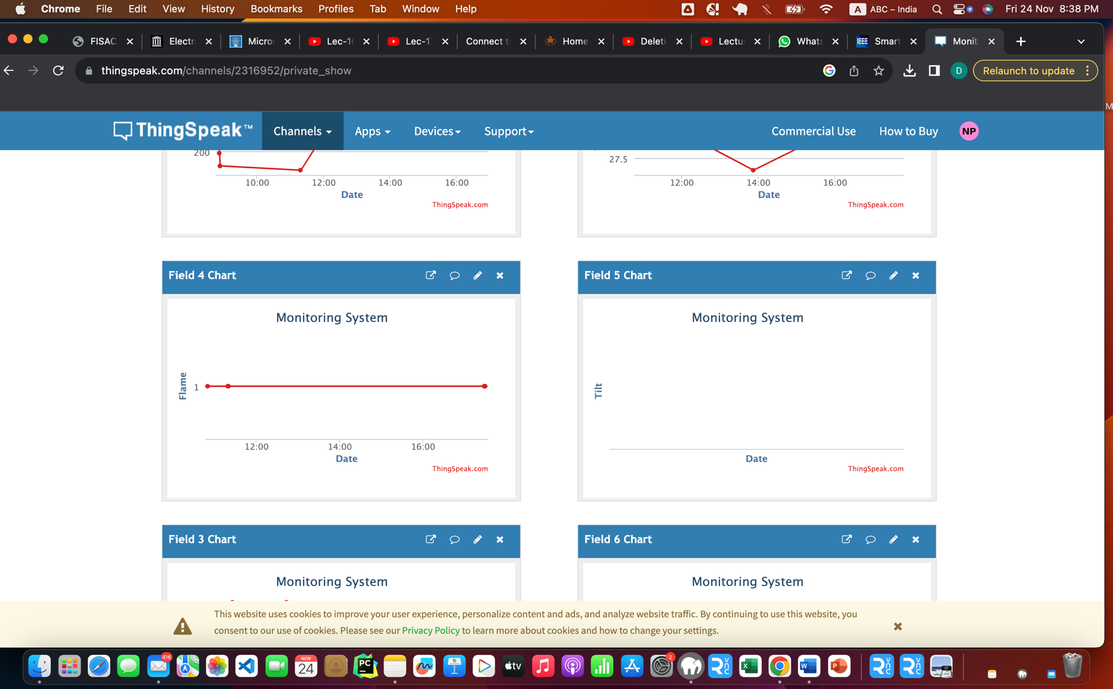

**Fig(6) Fig(7)**

1. **Intrusion System:**

**Fig(8) Fig(9)**

1. **Overflow/Waste Management System:**

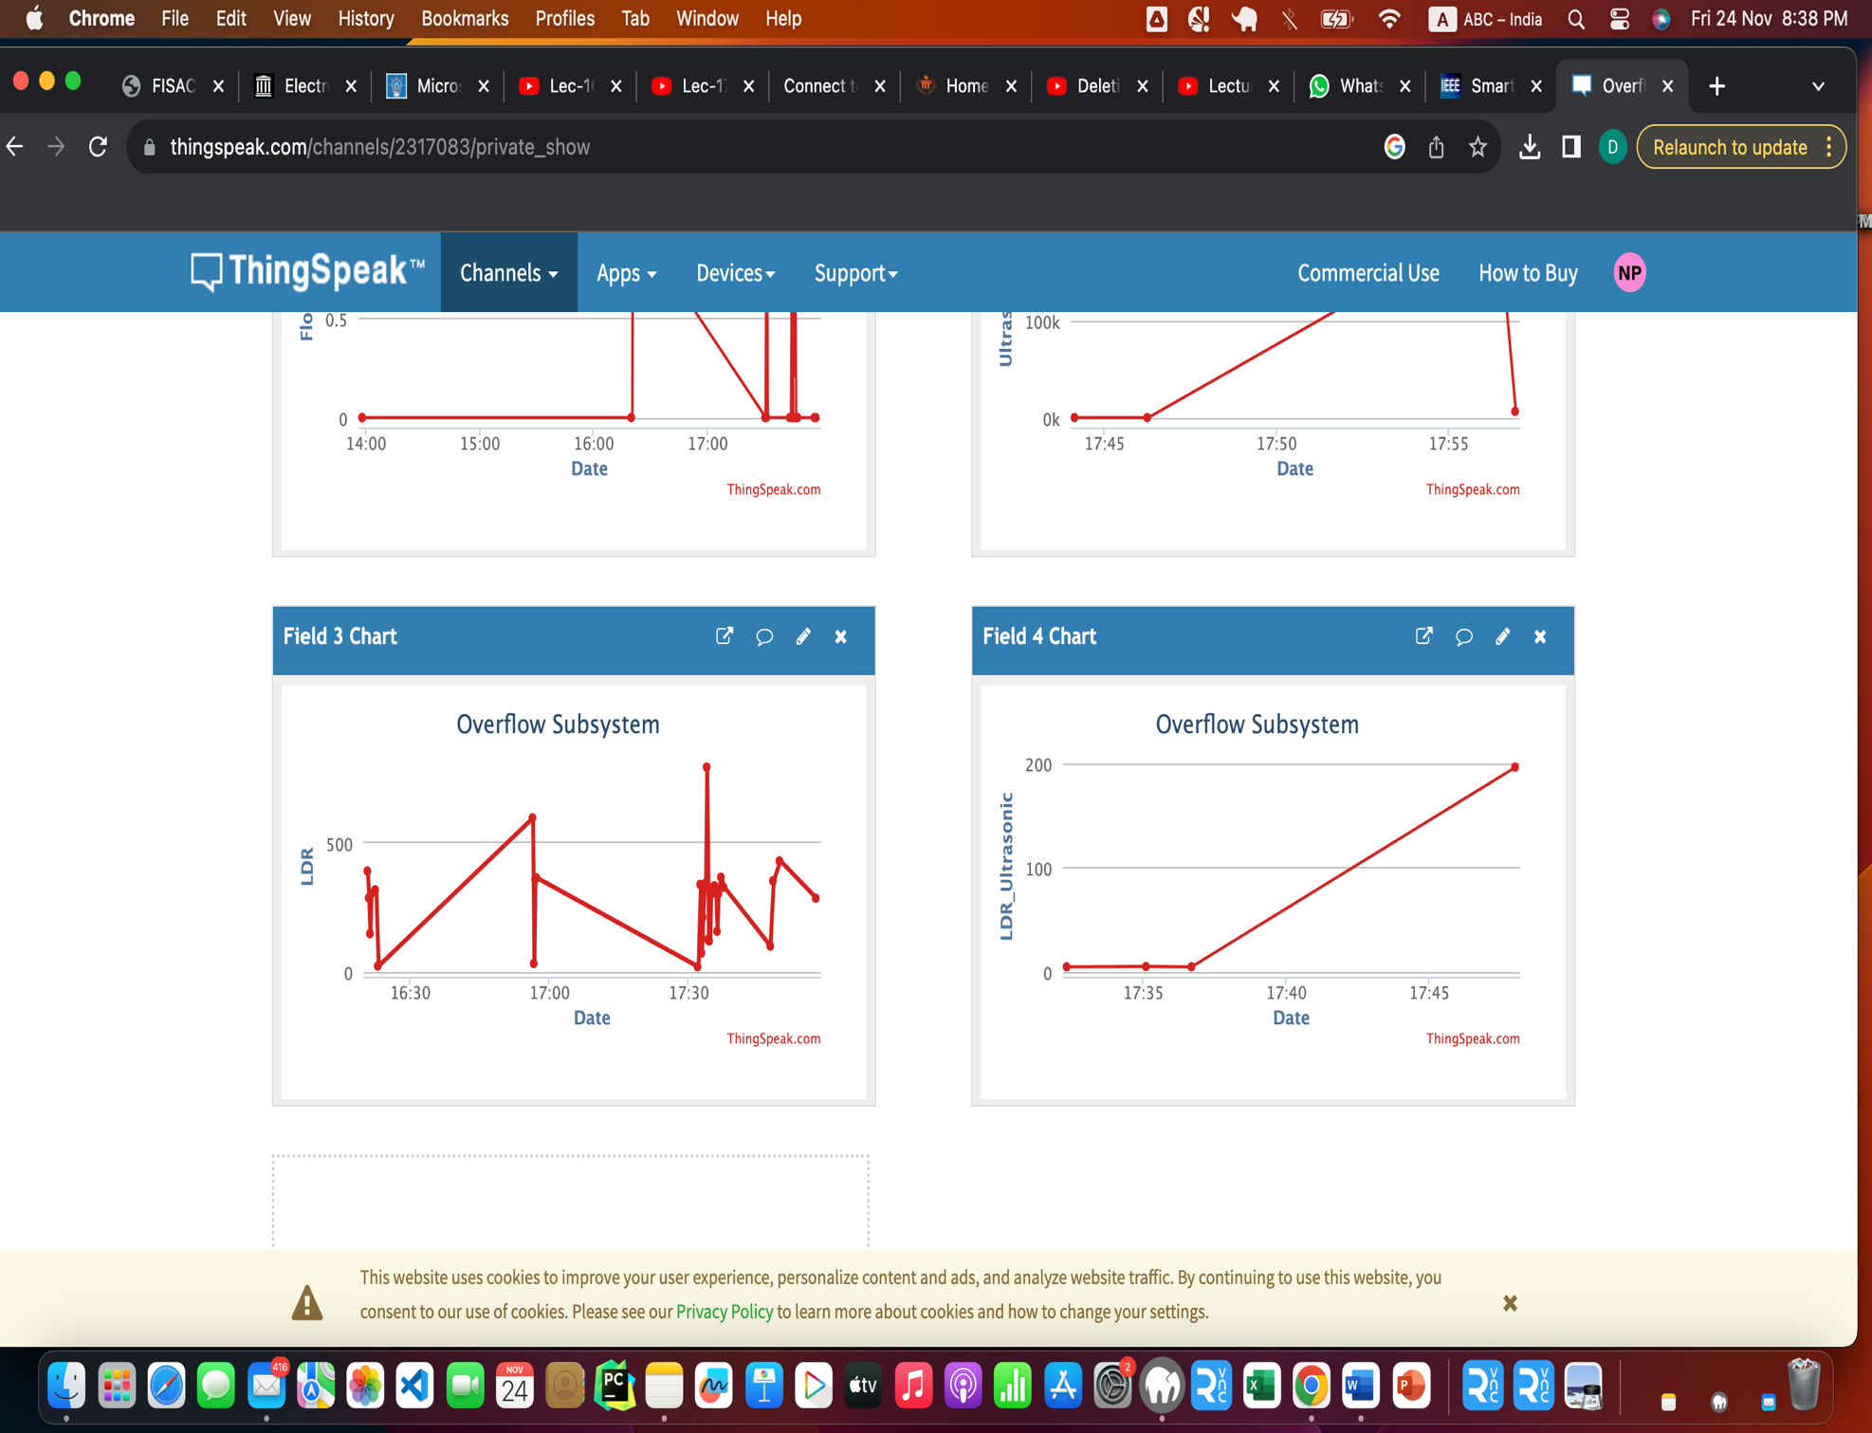

**Fig(10) Fig(11)**

Fig(12) Fig(13)

## **Conclusion and Future Work:**

The observation of drainage is a difficult task for the manual scavenger. To solve the problem of manual scavengers, a system has been proposed to reduce the effort in taking care of drainage and cleaning consult. This system is quite different from other systems, which help to overcome the drainage issue. This system includes various parameter like level of wastage, flow, and poisonous gases which is harmful to humans. The whole system is based on IoT which is monitored through Raspberry pi via sensor and update all the data of sensors on the cloud. This system will give us real-time updates via SMS, Email, and on the IoT website before the overflow of drainage, which is helpful for manual scavengers as well as people, who are living in their respective locality with a drainage issue. Presently , we worked out our project using conventional power source but to make it power efficient we can use a battery powered by solar energy. For this, solar panels could be installed on nearby street light which would provide power to noth street light and drainage. By this, we have tried to present a energy efficient and environmentally sustainable solution to our drainage problem.

1. **SDG’s achieved:**

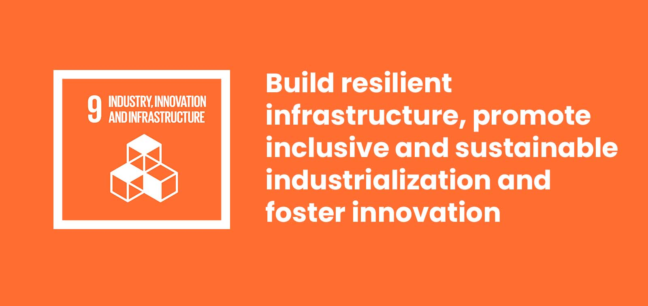

1. **REFERENCES:**

REFERENCES:

**Inspiration**:

<https://nevonprojects.com/iot-based-manhole-detection-and-monitoring-system/>

**Codes**:

https://www.instructables.com/Flame-Sensor-Raspberry-Pi/

https://www.instructables.com/Raspberry-Pi-water-alarm-system/

http://www.learningaboutelectronics.com/Articles/MQ-2-smoke-sensor-circuit-with-raspberry-pi.php

https://robu.in/raspberry-pi-ultrasonic-sensor-interface-tutorial/

https://robu.in/tilt-sensor-with-raspberry-pi/

**Additional references**:

https://www.raspberrypi.com/products/raspberry-pi-3-model-b-plus/

https://github.com

https://ieeexplore.ieee.org/document/7449655